**SIWA Analysis. Michael Cabas.**

There are 22 samples collected of chicken’s intestinal in these datasets and 771 different **Operational Taxonomic Units (OUT)**, the observed abundance of each feature can be observed in Figure 1. The microbiome is constituted mostly by Bacteria in every sample, also the figure shows that the there is mayor abundance of the Phylum *Firmicutes*.

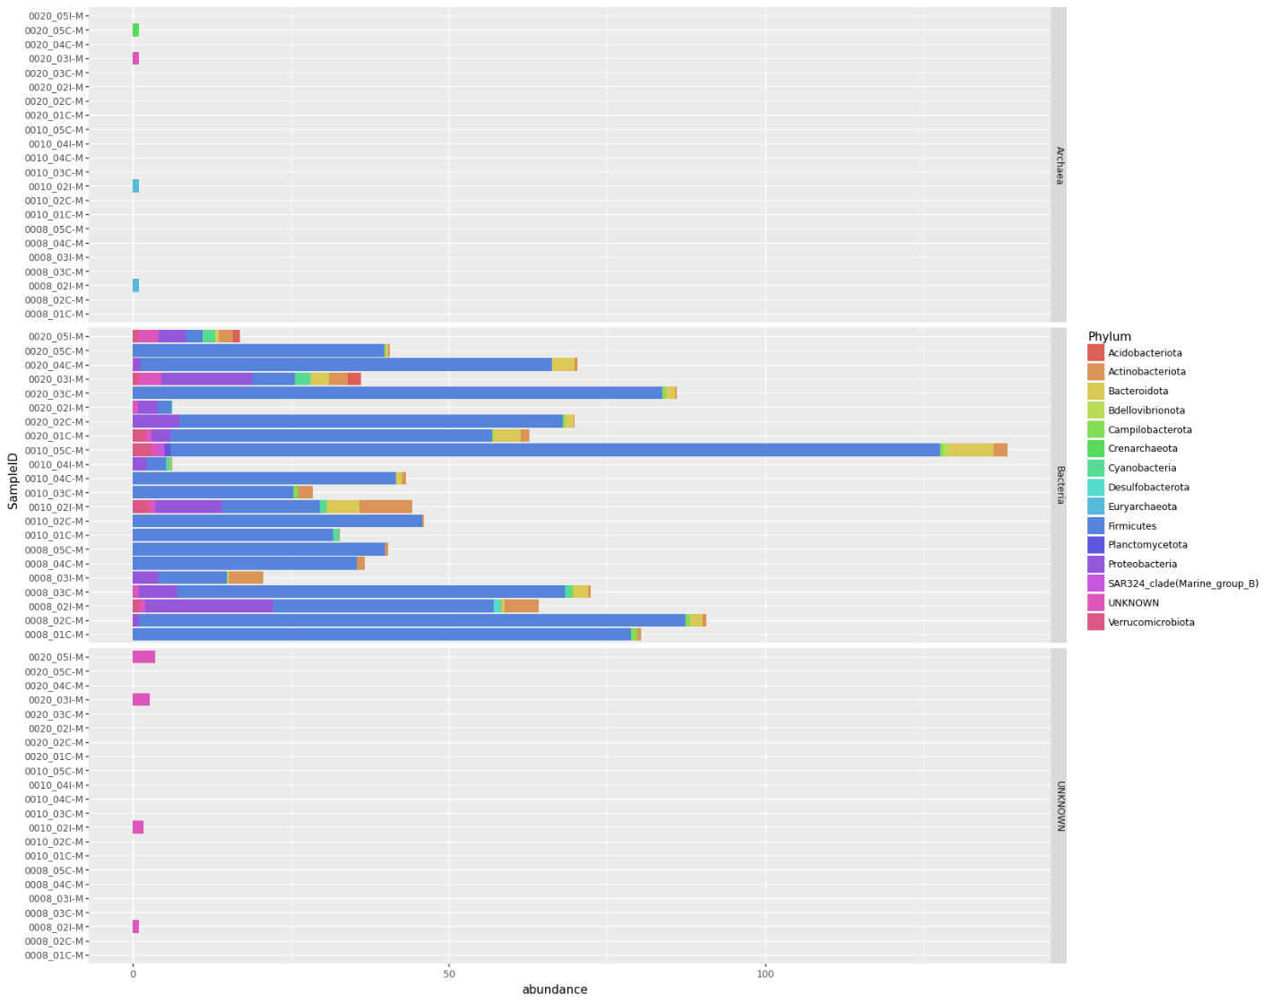

Figure 1. Comparison of abundance Phylum in microbiome of intestinal chicken’s samples. Archaea (Top), Bacteria (Mid), UNKNOWN (Bottom). Build in Python with plotnine.

Samples were collected from two different locations in the intestines and have different microbial composition, in Figure 2, Samples presents different microbial populations just for the *Phylum Firmicutes*, samples that were collected from the Cecum (C), shows have more abundance of populations from the order of *Paenibacillales*, *Lactobacillales* and *Clostridiales.* In contrast with samples collected from theIleum (I), that have more abundance of orders *Streptosporangiales* and *Lactobacillales.* In addition, the graph display that samples collected form the Cecum have more relative abundance than the samples collected from the Ileum.

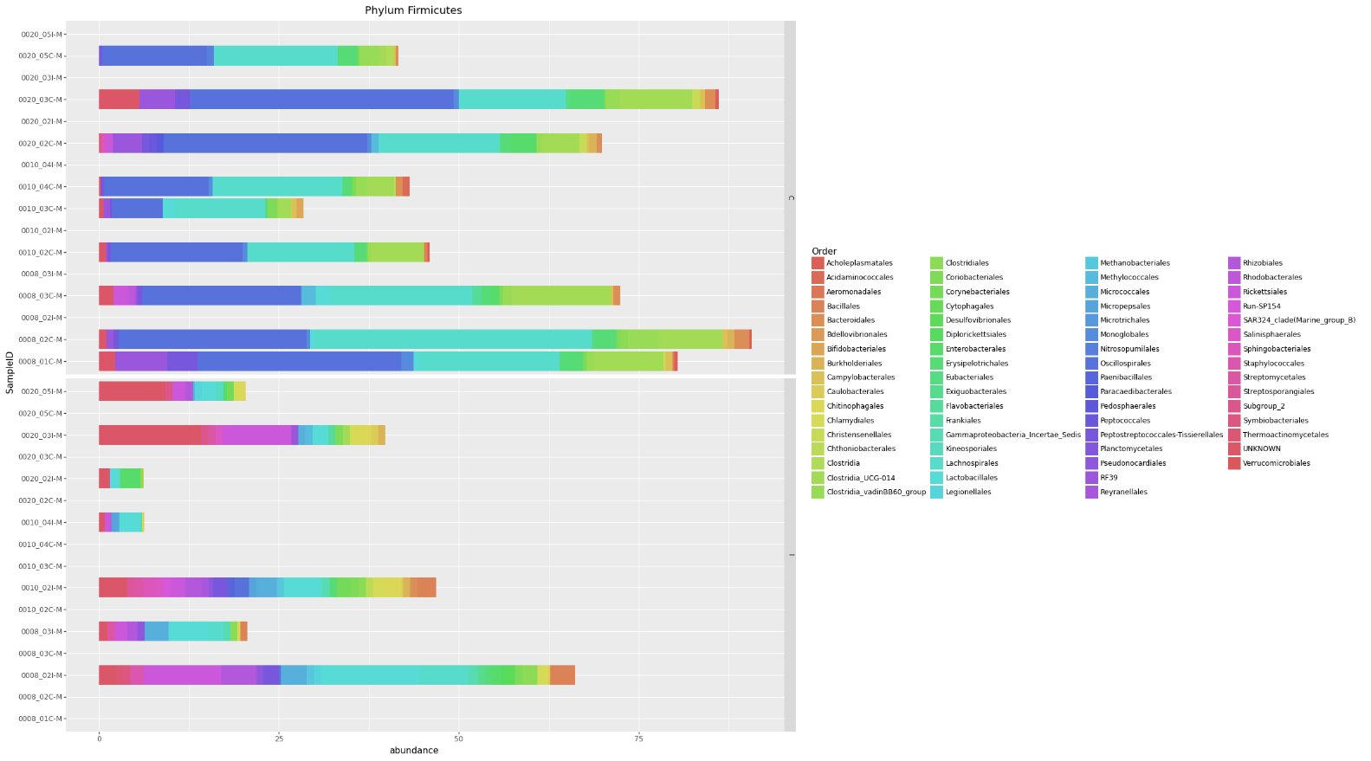

Figure 2. Comparison of relative abundance of Phylum Firmicutes in microbiome of intestinal chicken’s samples. In Color are listed different Orders of the phylum Firmicutes. Sample location: Cecum – C (Top), Ileum – I (Bottom). Build in Python with plotnine.

A principal coordinates analysis was conducted to evaluate the beta diversity in sample location microbiome of intestinal chicken’s samples (Figure 3). PCoA 1 and PCoA 2 are explaining most of the variation in the model (0.9751, 0.5085). The polygons in the figure represents sample location, Cecum (C) and Ileum (I), are very close to each other, due to the polygons overlapping, these locations share similar microbial populations, but the distance between the center of each polygon show difference between the abundance of these microbial populations.

Figure 3. Principal coordinates Analysis of beta diversity in microbiome of intestinal chicken’s samples. Environmental variables analyze is sample Location: Cecum (C), Ileum (I). Method use was “z” [2]. Build in R with vegan Library.

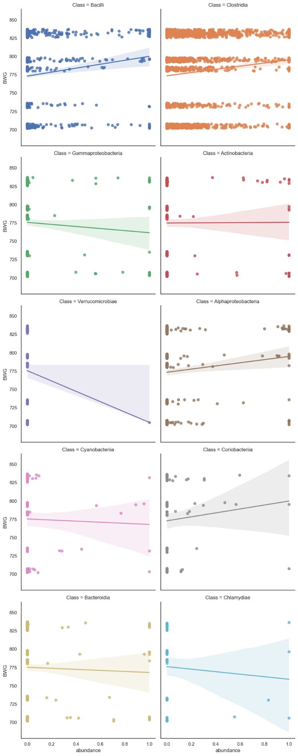

Figure 4. Correlation analysis of relative abundance of the 10 most abundant microbiome classes vs. Body Weight Gain (BWG) in microbiome of intestinal chicken’s samples. Build in Python with seaborn, UNKNOWN was not considered for this analysis.

A correlation analysis was performed to analyze the relation between relative abundance of the ten most abundant classes in the microbiome and the chicken’s Body Weight Gain (BWG) (figure 4). A positive correlation was found for *Bacilli*, *Clostridia, Alphaproteobacteria* and *Coriobacteriia* classes, meaning that any increase in the chicken’s BWG may increase the presence of these bacteria in the gut microbiome. A negative correlation was display for Verrucomicrobiae. The other classes consider seems to have no correlation.

**Summary.**

There are 22 samples collected of chicken’s intestinal in these datasets and 771 different **Operational Taxonomic Units (OUT)** in the otu_taxa_ws file, this file has information of abundance of each sample (Features Table) associate to a OTU, and also have taxonomic related information (Taxonomic table). Metadata provide environmental variables related to 16 of the samples collected, that give us information about: Animal Type, Sample Location and Body Weight Gain (BWG). otu_taxa_ws and metadata file are connected by SampleID, in a one-to-one relation.

For the exploration data analysis (EDA), multiples methods were applied to have a broad vision of the data, feature abundance was normalized to be able to perform different compare abundance data in different analysis without being affected by the scale. Different filters were applied to select most abundant taxonomic groups to be represented in the figures. For the Principal coordinates Analysis of beta diversity, method = “z” was selected to calculate dissimilarities between samples (equation: *"z" = (log(2)-log(2*a+b+c)+log(a+b+c))/log(2), [1]*), multiple methods were applied until found one that display clear difference between the Sample Location.

From overall analysis in can be conclude that: the microbiome of intestinal chicken sample is mostly composed of Bacteria, there is similar microbiome in Cecum and Ileum, but there is different abundance of taxonomical groups. A slight positive correlation between relative abundance and BGW was found for *Bacilli*, *Clostridia, Alphaproteobacteria* and *Coriobacteriia* classes, but more information about other samples might be needed to increase the correlation. To expand the previous analysis, it must be considered other environmental variables such as age, diet, breed, and health. And to compare this analysis with peer reviewed papers to be able to have insights about the health of the chicken, change of microbiome with age and diet implementation in chickens that improve gut health.

**Referencias**.

[1] Lennon, J. J., Koleff, P., Greenwood, J. J. D., & Gaston, K. J. (2001). The geographical structure of British bird distributions: diversity, spatial turnover and scale. *Journal of Animal Ecology*, *70*(6), 966-979.

[2] Koleff, P., Gaston, K. J., & Lennon, J. J. (2003). Measuring beta diversity for presence–absence data. *Journal of Animal Ecology*, *72*(3), 367-382.